**GOVERNMENT THIRUVARUR MEDICAL COLLEGE**

**DEPARTMENT OF OPHTHALMOLOGY**

and

**DISTRICT BLINDNESS CONTROL SOCIETY, THIRUVARUR**

**40th EYE DONATION FORTNIGHT – 2025.**

**PROGRAM:**

**1. Eye donation awareness camp at Government Upgraded Primary Health Center, Alangudi.**

**2. Rangoli competition for Undergraduate Medical students and Paramedical students.**

**3. Poster presentation by Undergraduate Medical students.**

**4. Eye Donation Awareness Rally, inauguration by District Collector.**

**5. Eye donation Pledge, Awareness speech, Prize distribution, presided by Dean, GTMC at Department of Ophthalmology.**

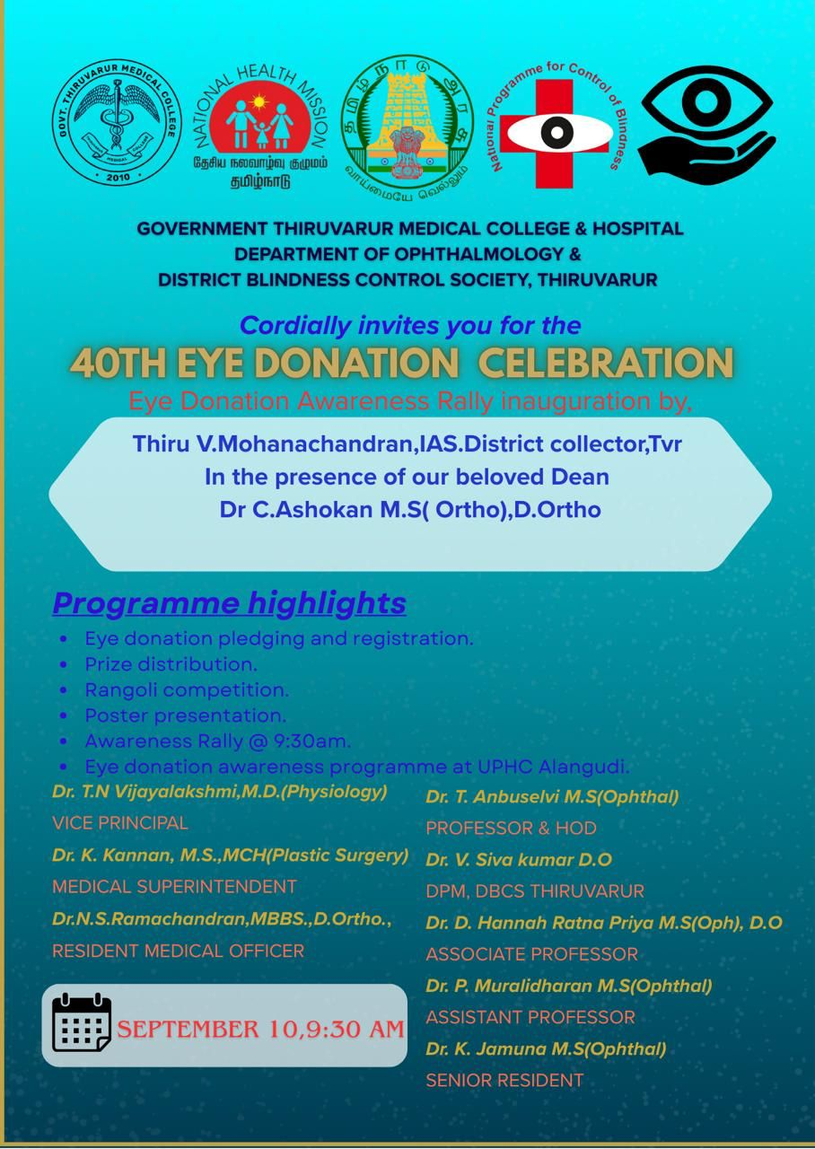

**As a part of National Eye Donation Fortnight 2025, Eye Donation Awareness program was conducted at Govt upgraded PHC Alangudi under the guidance of Dean , GTMC.**

**Dr. V. Sivakumar, District Program Manager, DBCS, Dr. T. Anbuselvi, Professor and HOD, Department of Ophthalmology, GTMC, Dr. Kathiravan, Block Medical Officer, Mr.Swaminathan, PMOA and Mrs. Nithya, Optometrist participated in the program along with 40 to 50 patients and public people.**

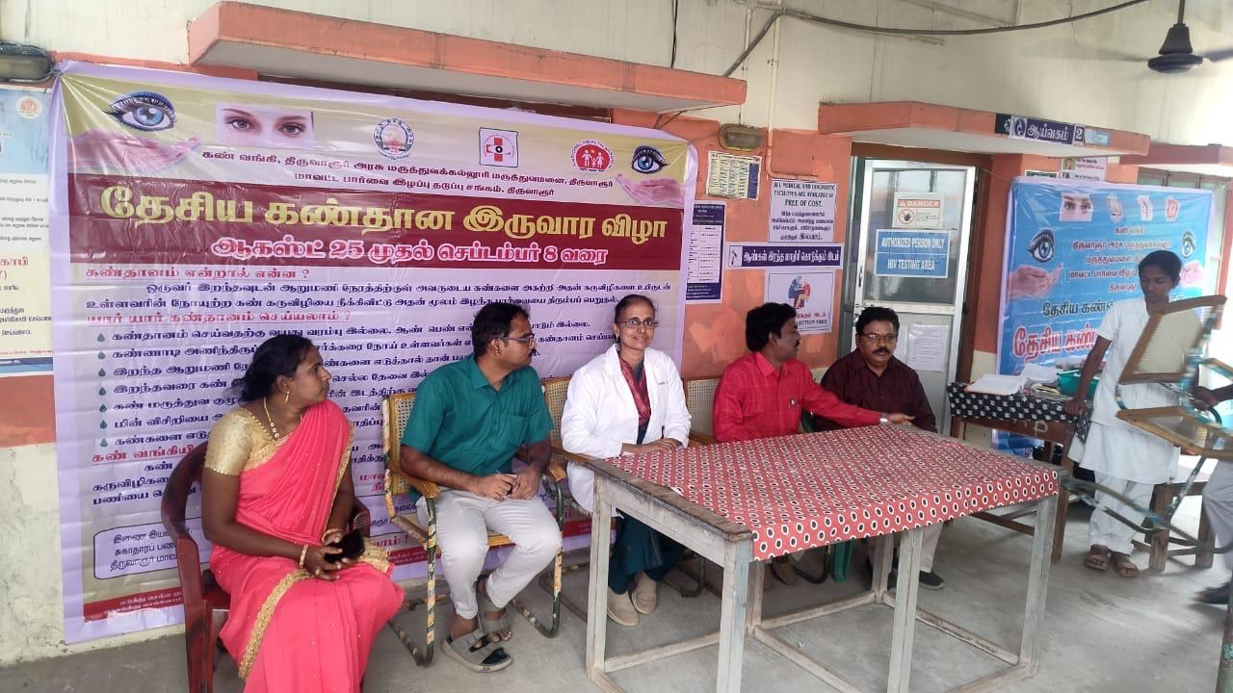

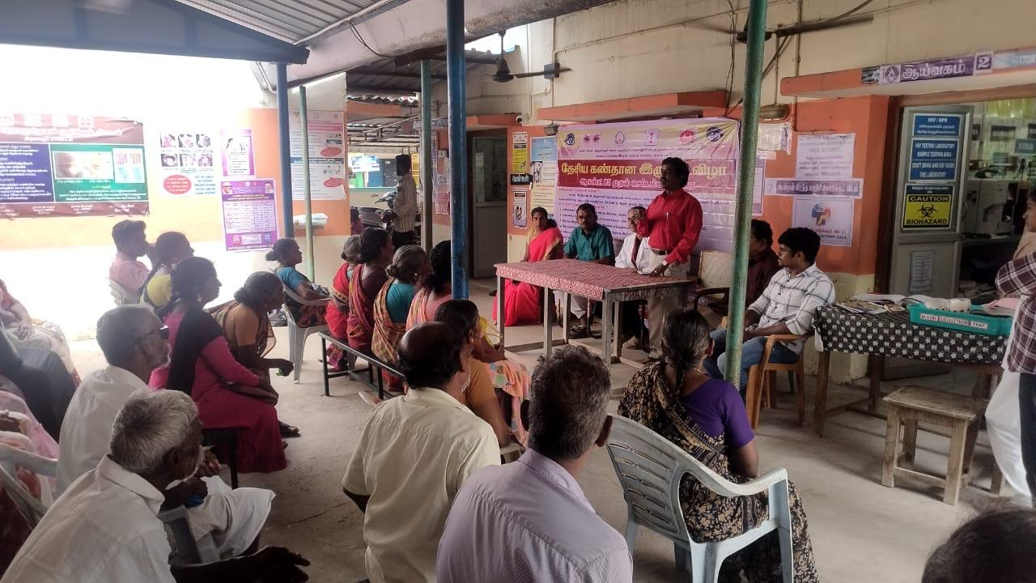

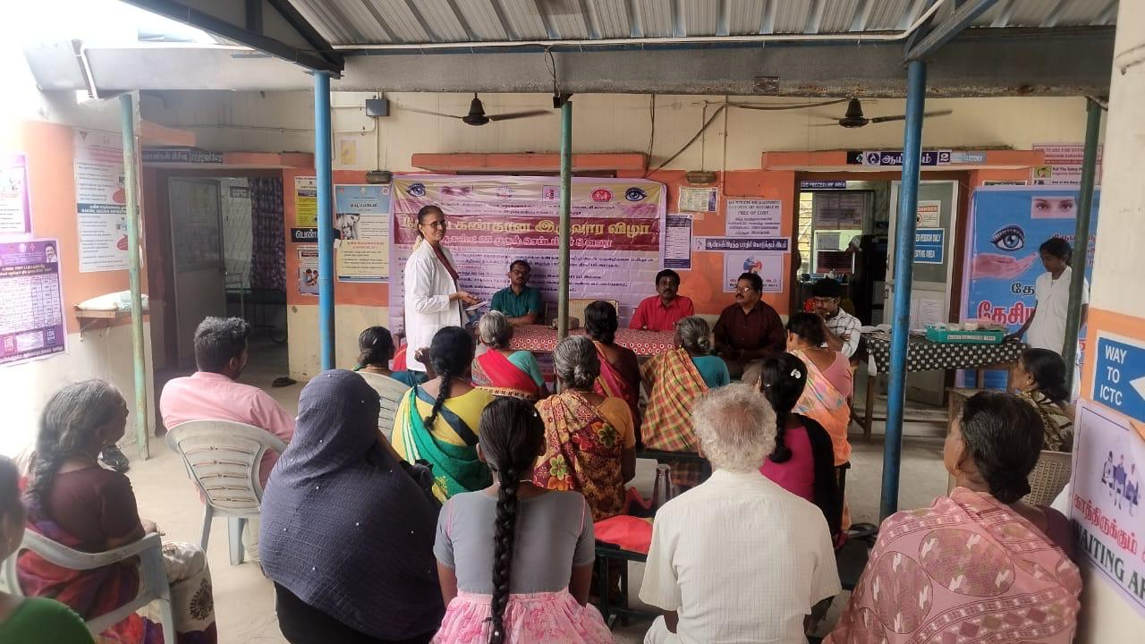

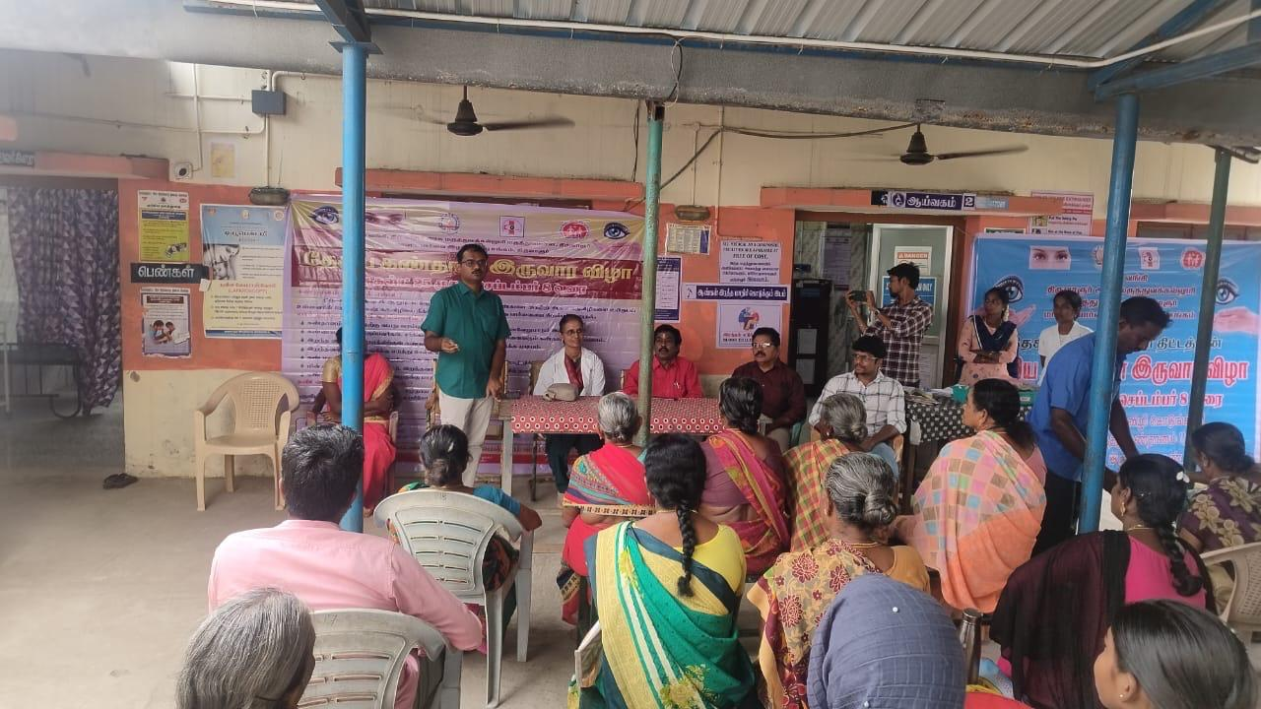

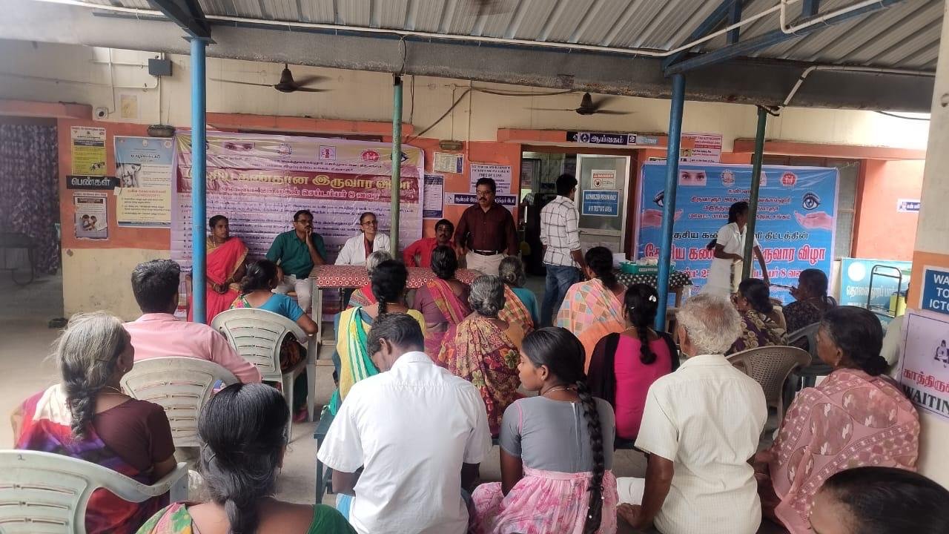

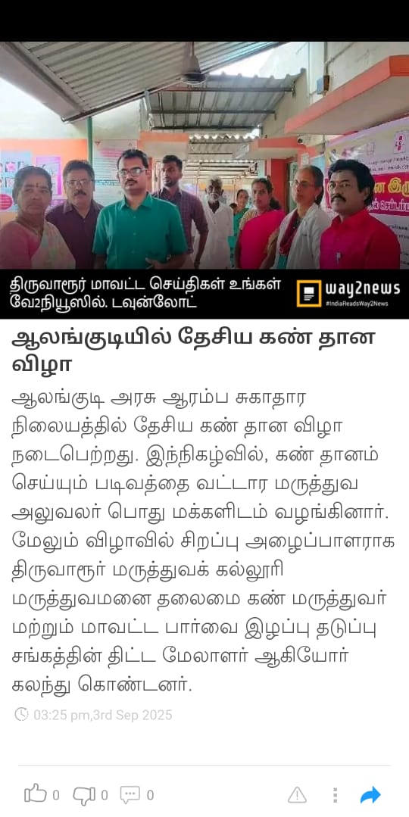

**Rangoli competition for Undergraduate and Paramedical students**

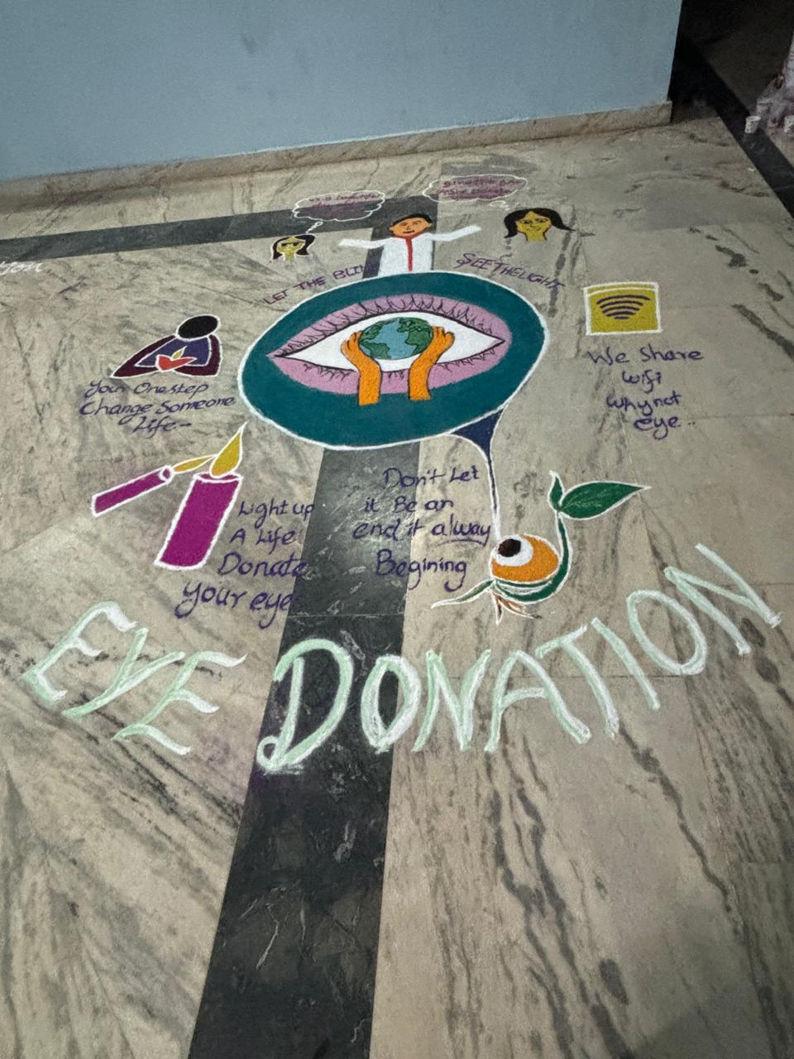

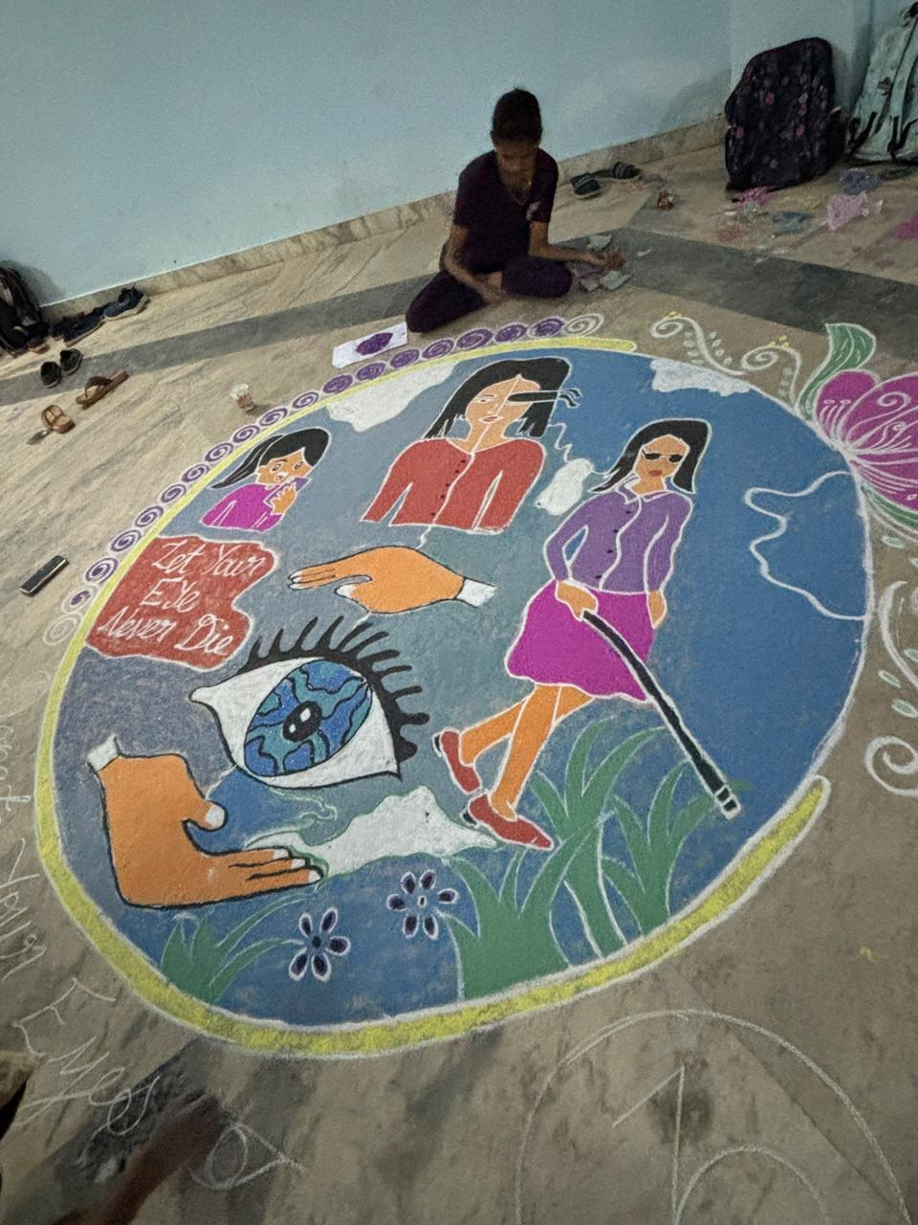

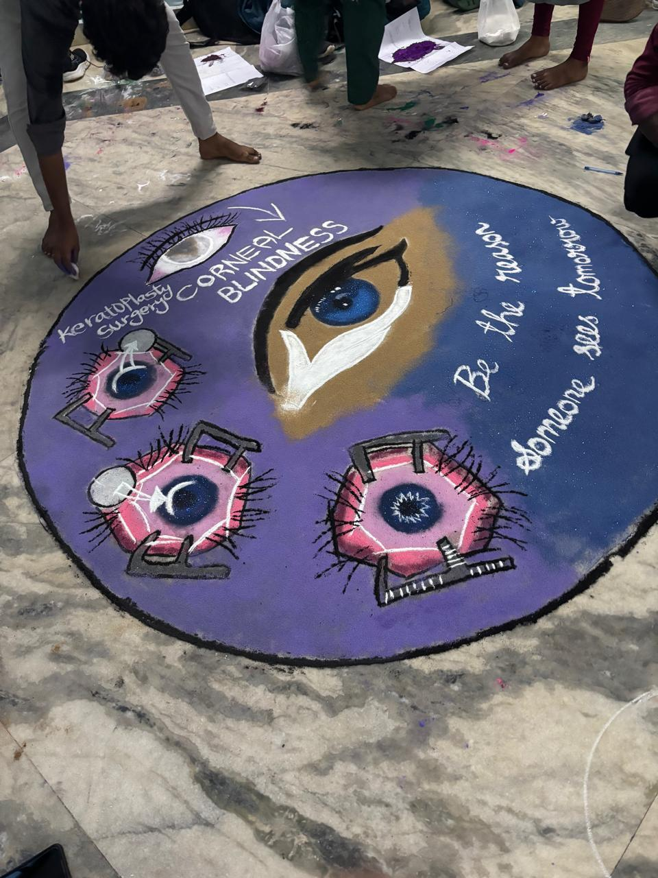

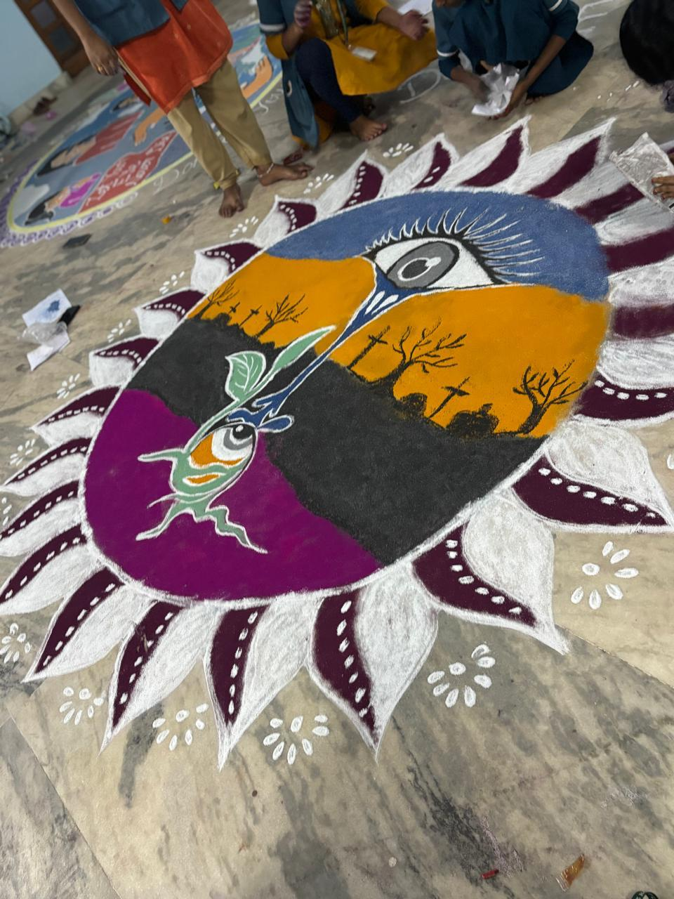

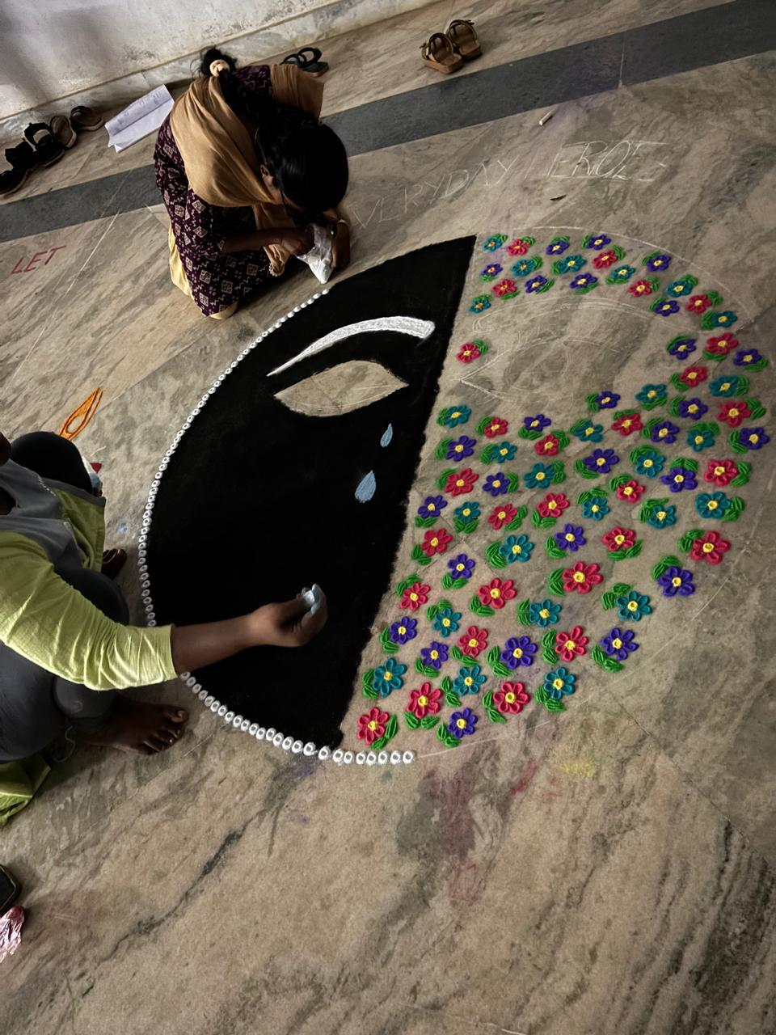

**Poster presentation by Undergraduate medical students:**

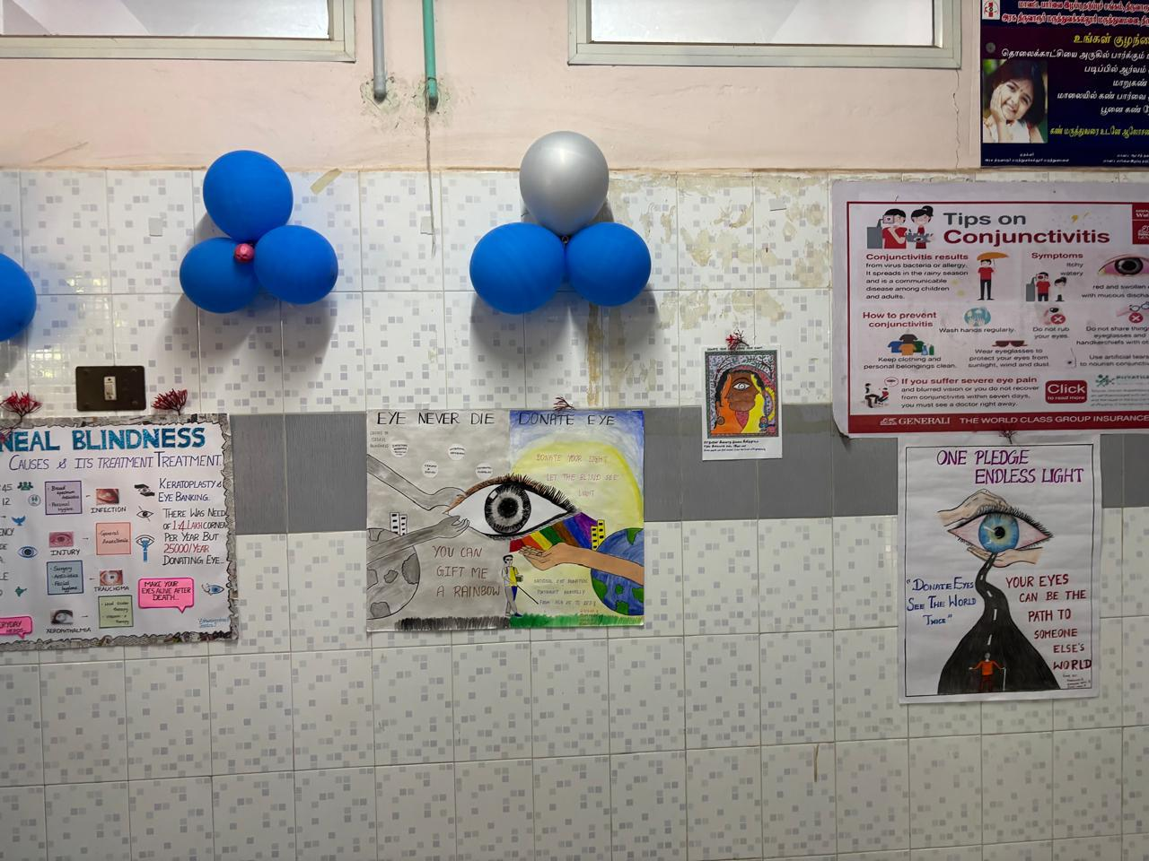

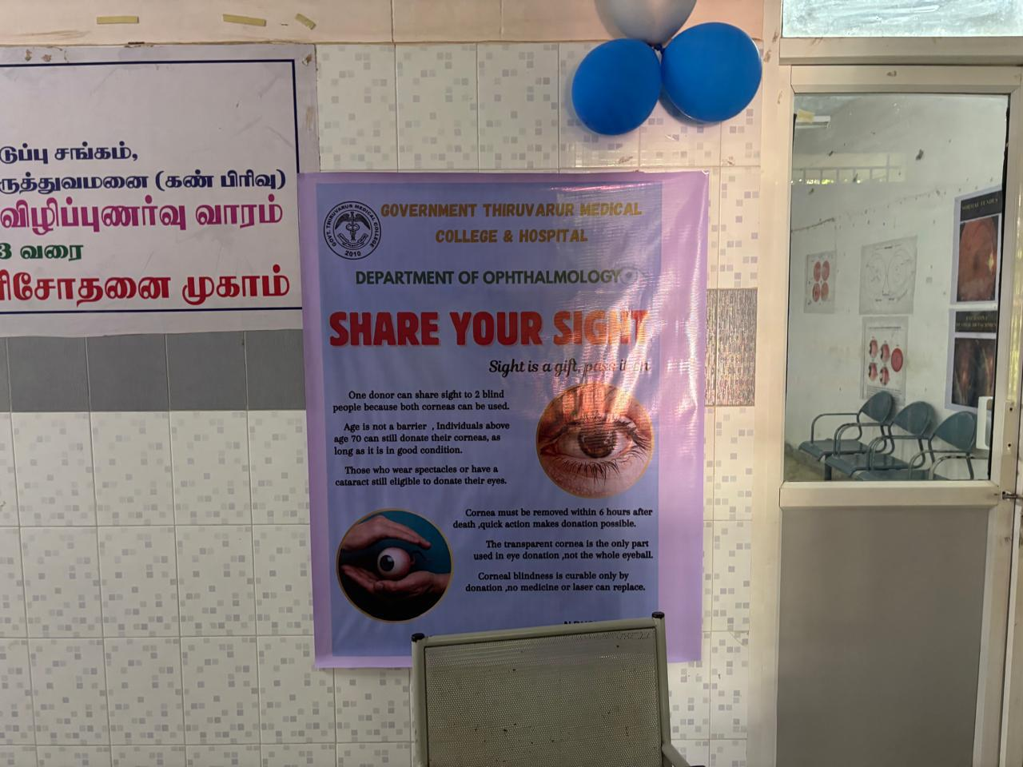

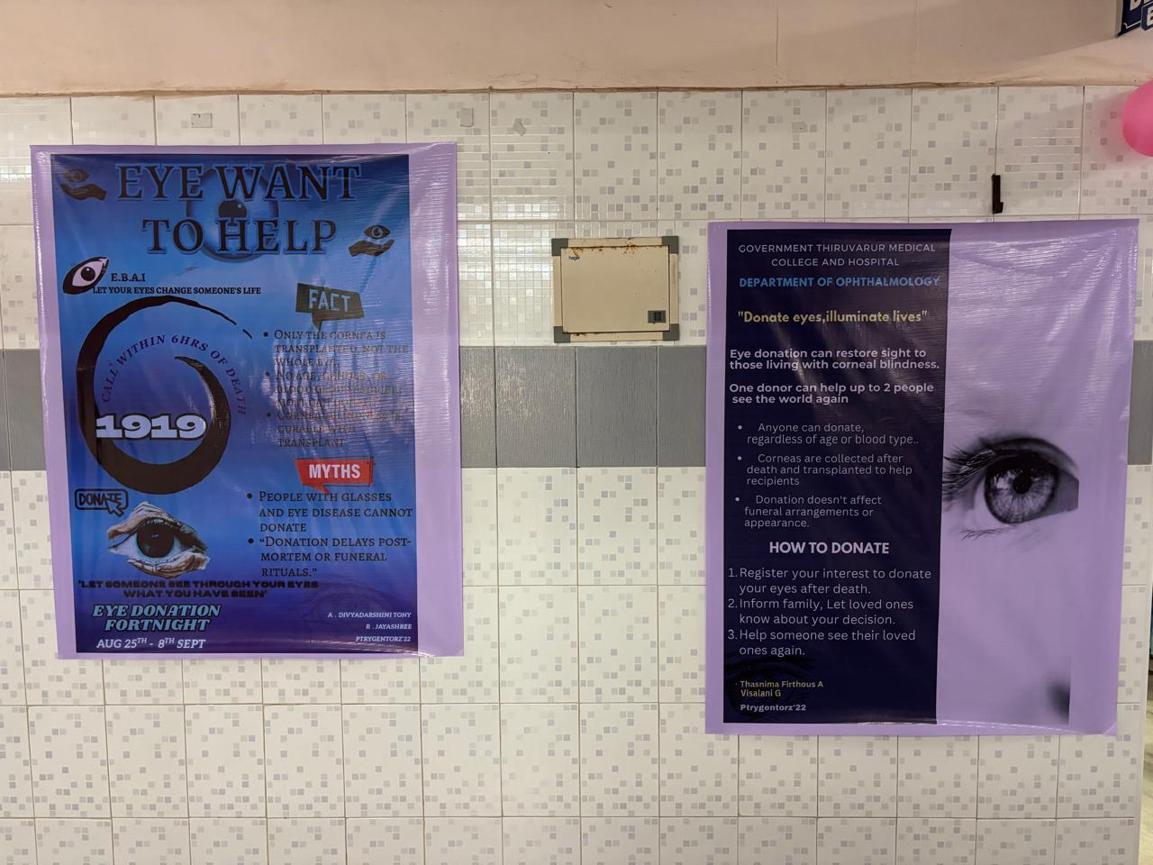

**District Blindness Control Society, Thiruvarur and Department of Ophthalmology conducted Eye Donation Awareness Rally at GTMC.**

**The rally was inaugurated by Thiruvarur District Collector in the presence of Dean, GTMC. Medical Superintendent, Vice Principal, Resident Medical Officer, ARMO, Professors, Associate Professors, Facuties of various departments, Matrons, Nursing Staffs, Undergraduate Medical students and Paramedical students participated in the Rally. Slogans about Eye donation was chanted during the Rally. Pamphlets about eye donation awareness was distributed to the public.**

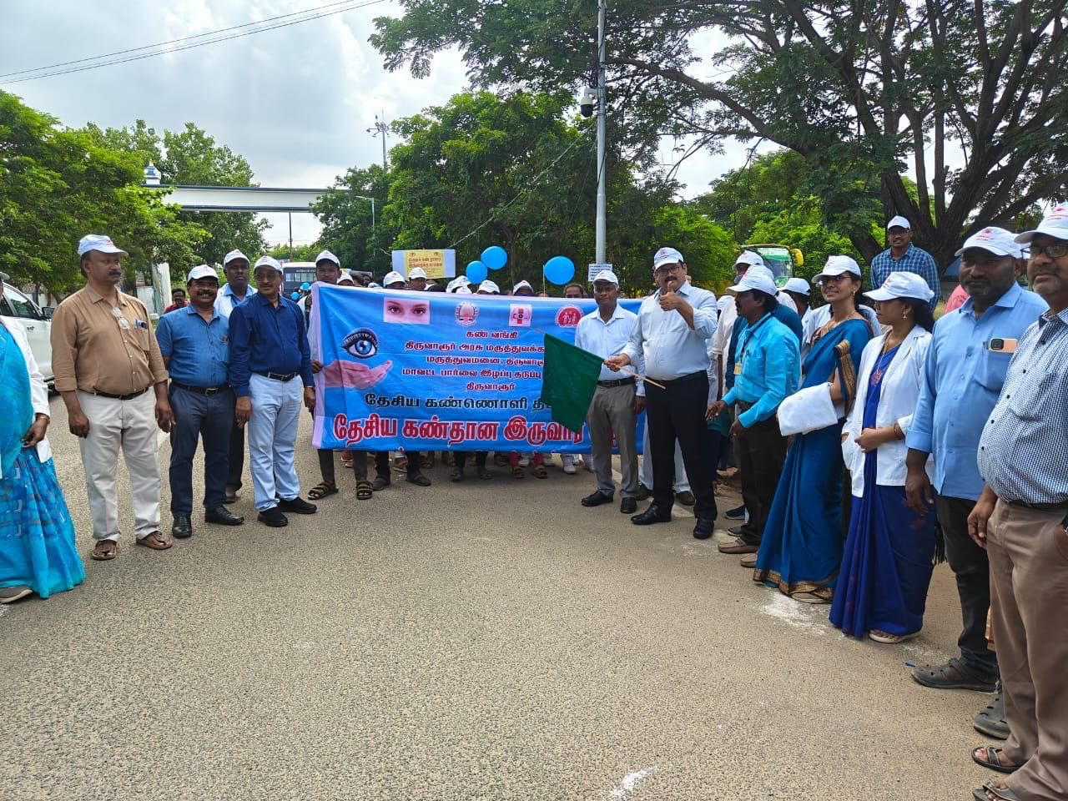

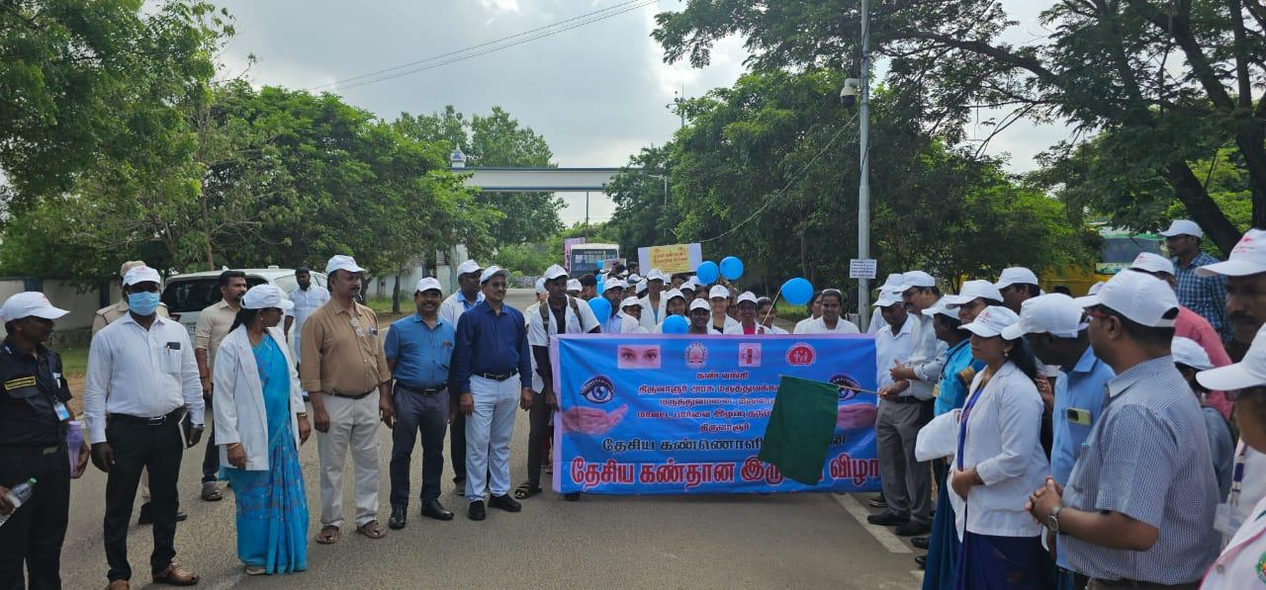

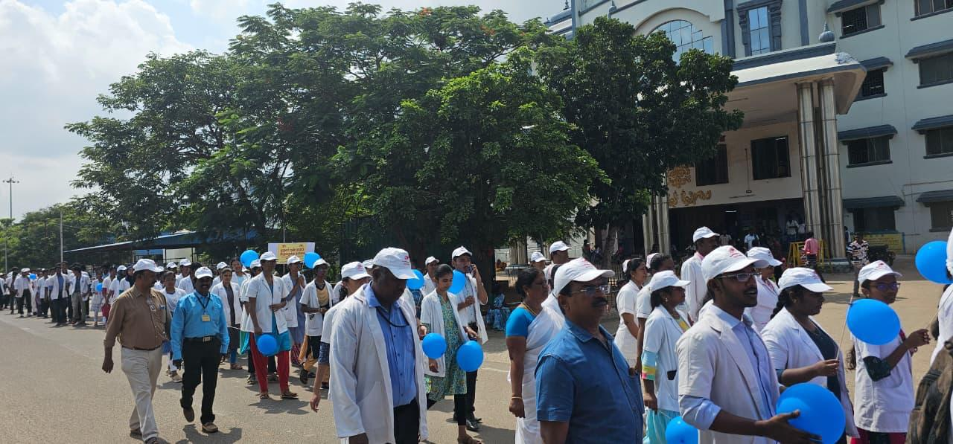

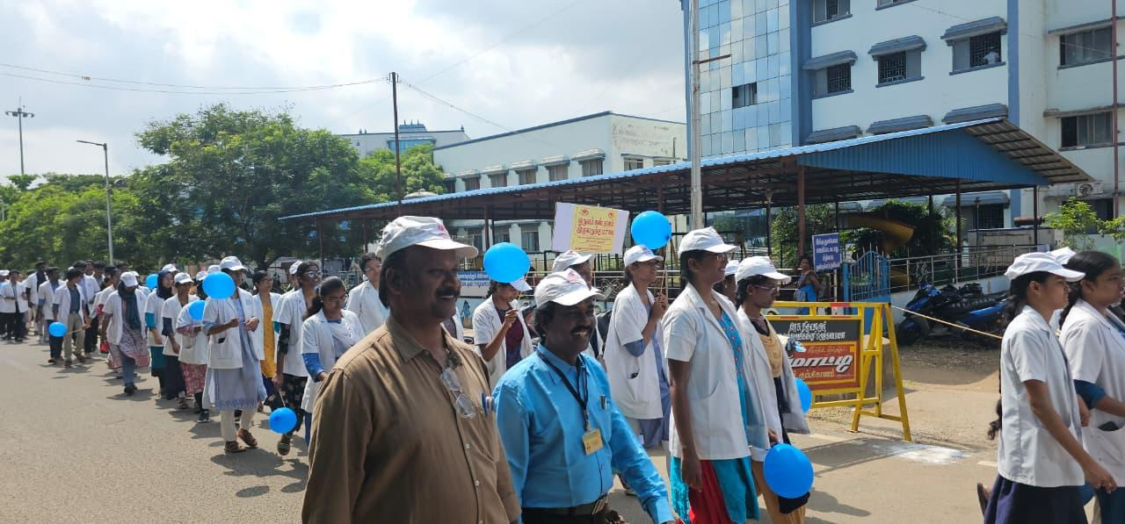

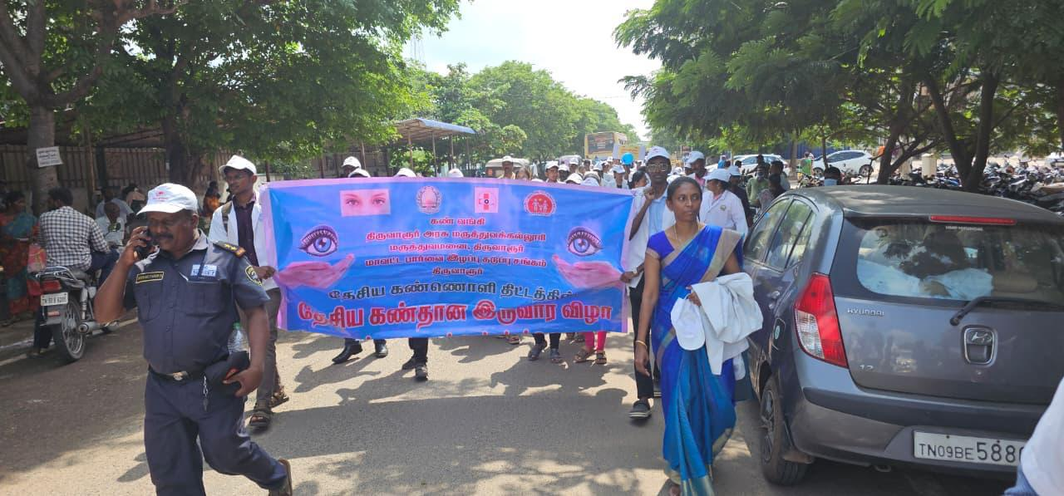

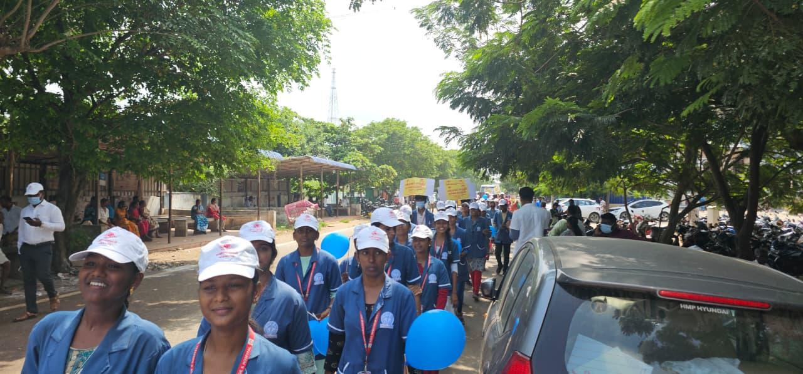

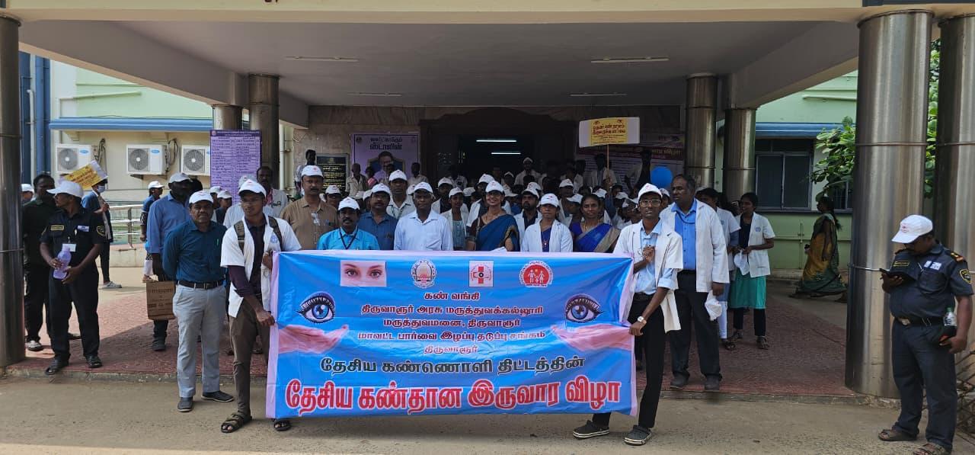

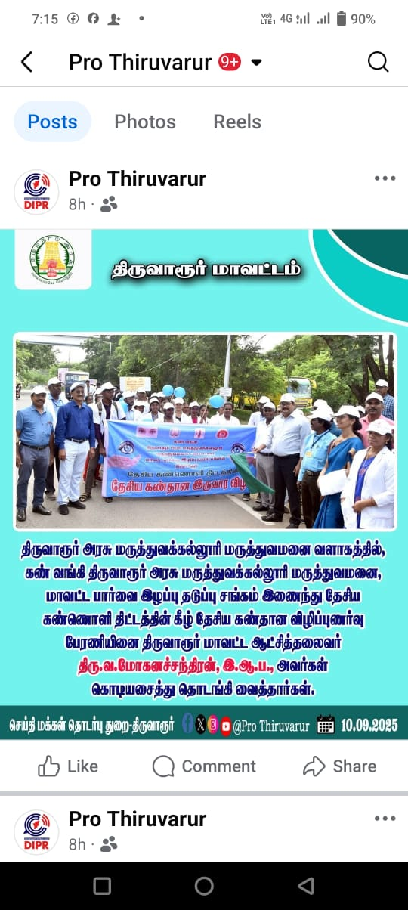

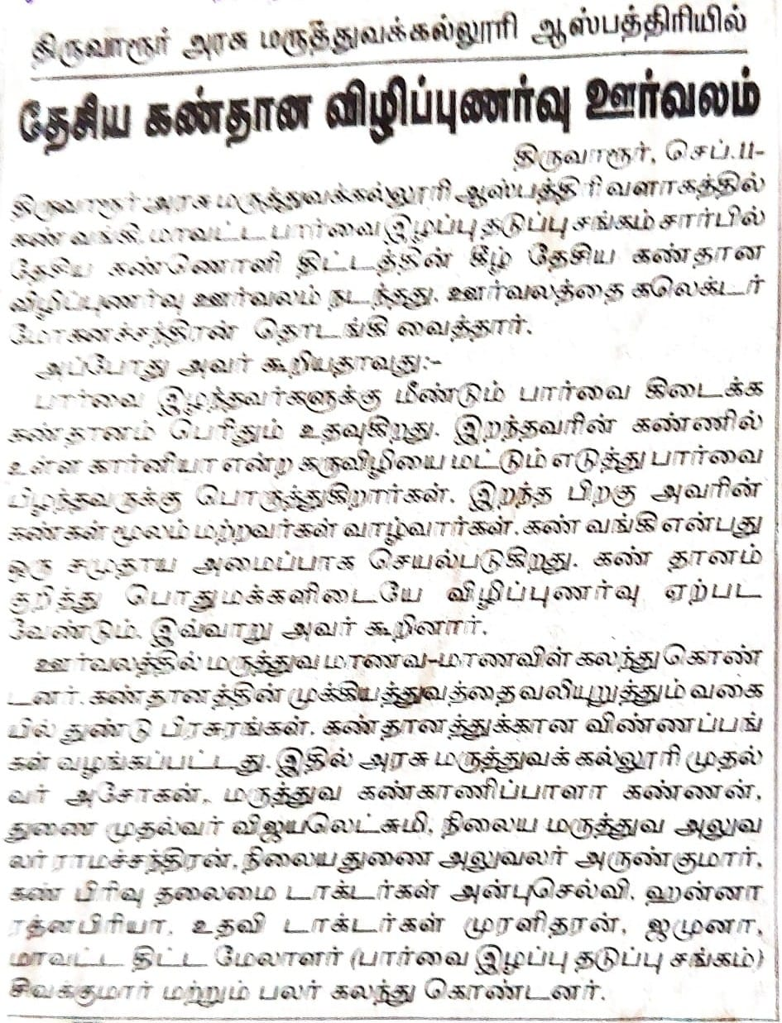

**Eye donation pledge and registration:**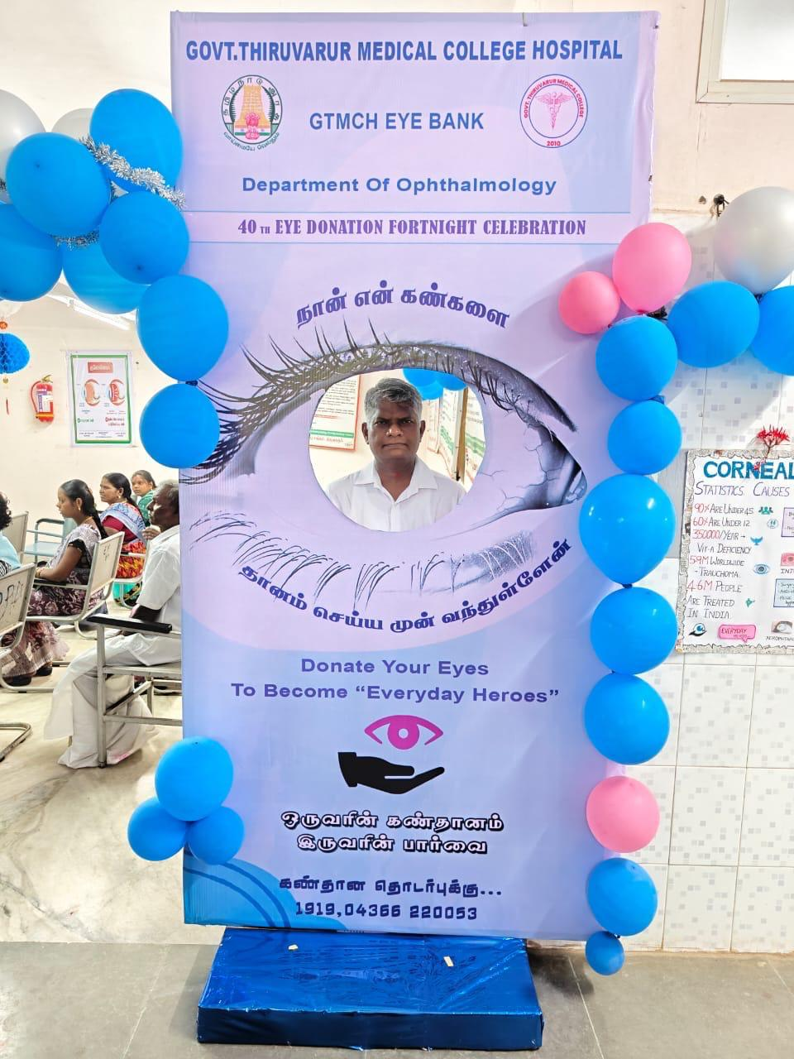

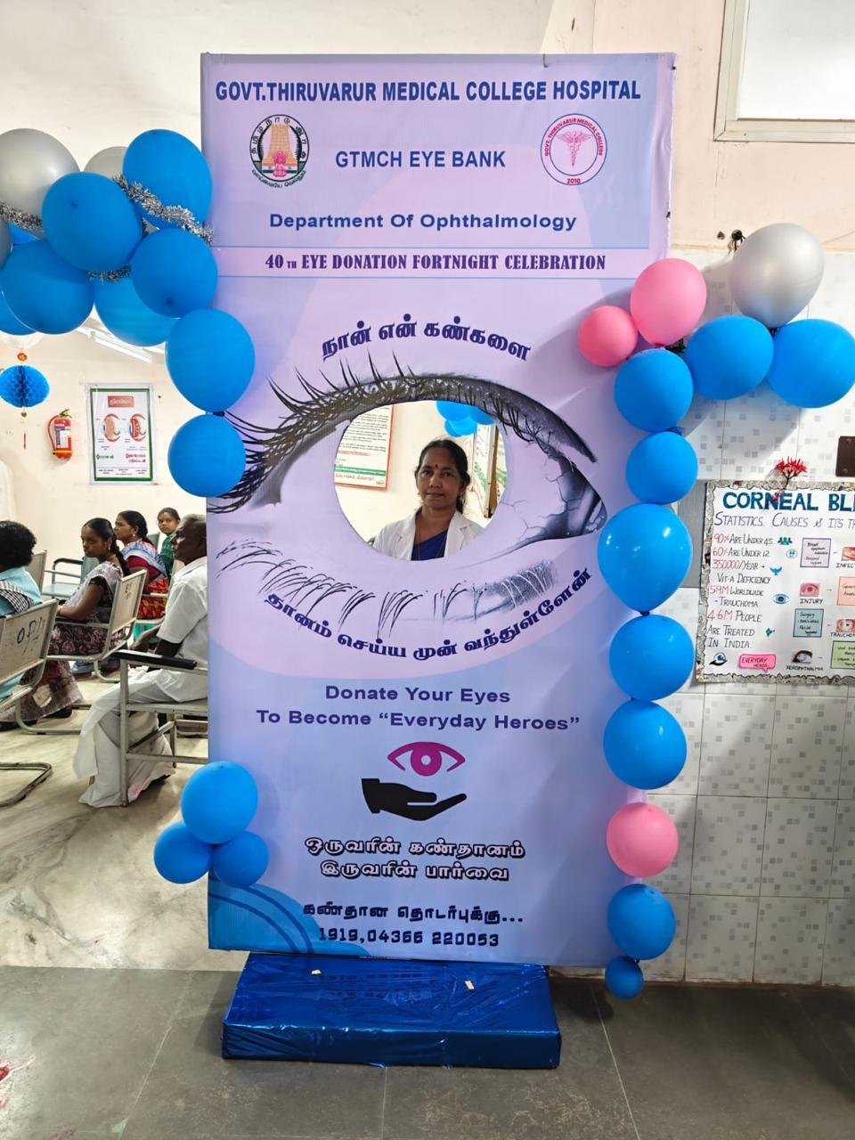

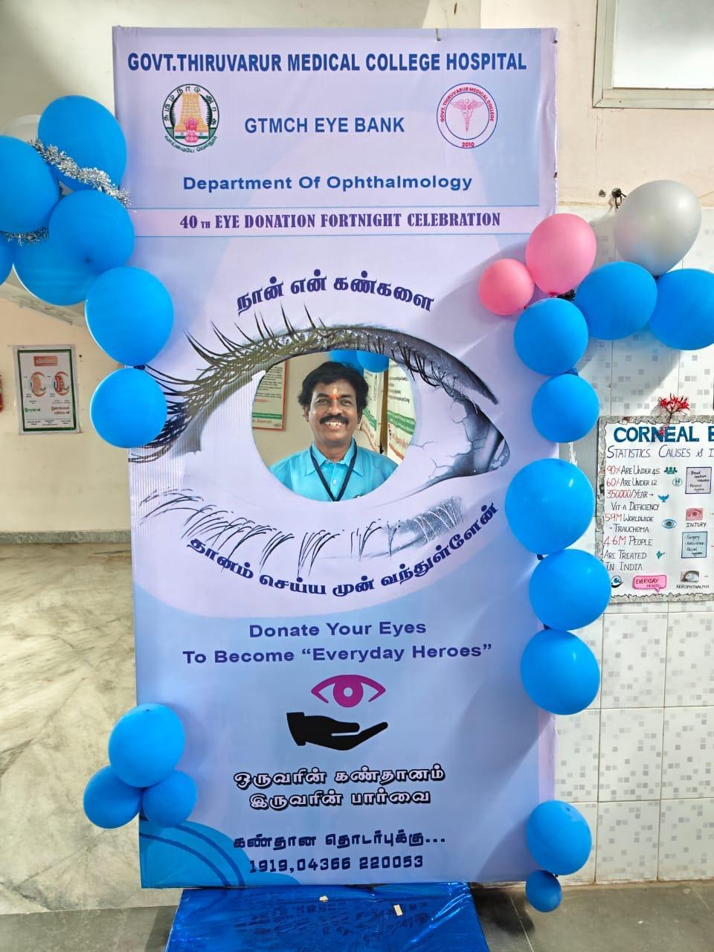

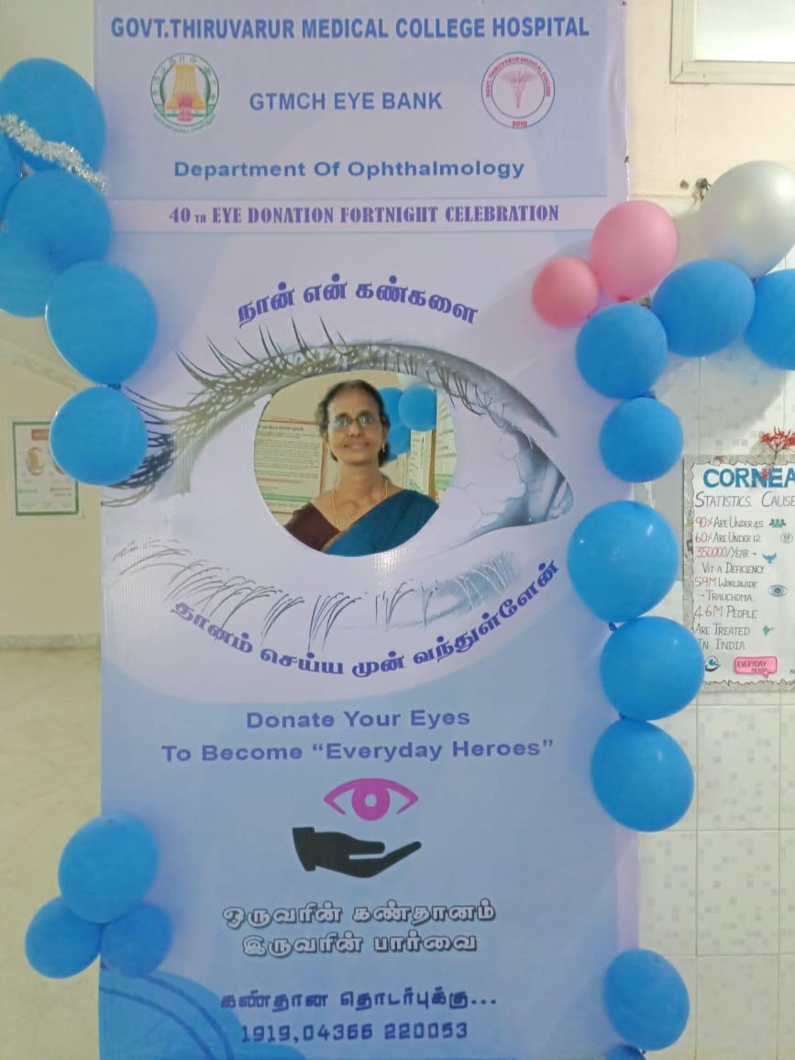

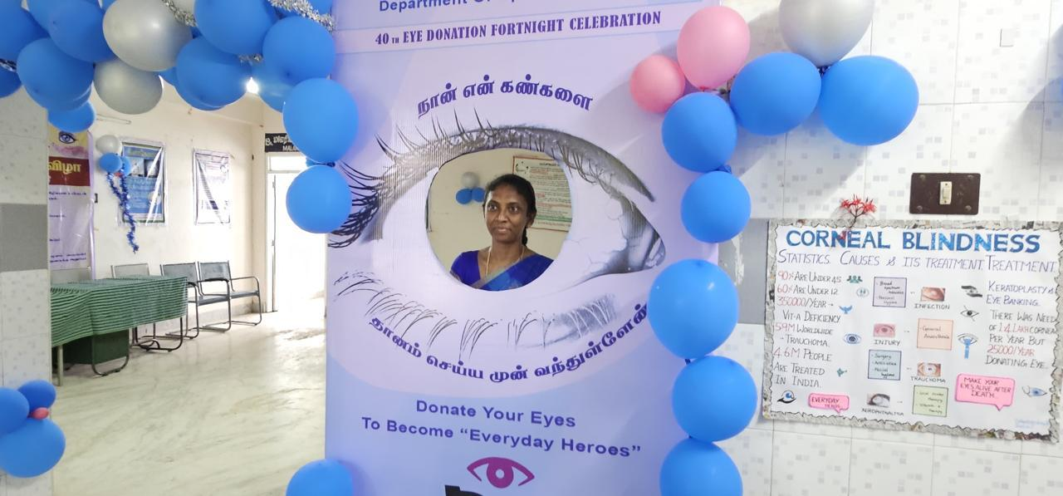

**Awareness speech, and prize distribution, presided by Dean GTMC.**

